

National Treasury: Neighbourhood Development Programme:

Management Policy

|  |  |
| --- | --- |
| Compiled by: | D Cohen and D Korff |
| Author(s) | D Cohen |
| Reviewed by: | D Van Niekerk |
| Document Version: | V0.2 |
| Release Date: |  |
| Review Date: |  |

Document Classification:

Confidential

NDP Management Policy_DC_Draft_v0.1

Document Approval

(Indicate ‘N/A’ where not applicable)

|  |  |  |  |
| --- | --- | --- | --- |
| Action | Name & designation | Signature | Date |
|  |  |  |  |
|  |  |  |  |
|  |  |  |  |
|  |  |  |  |
|  |  |  |  |
|  |  |  |  |

Document Revision Control

|  |  |  |  |
| --- | --- | --- | --- |
| **Revision** | **Date** | **Author** | **Summary of changes** |
| V0.1 | 22/01/2013 | Douglas Cohen | Draft |
| V0.2 | 18/02/2013 | Douglas Cohen | Updated Draft |
|  |  |  |  |
|  |  |  |  |
|  |  |  |  |
|  |  |  |  |

Glossary of Abbreviations and Terms

| Abbreviation / Term | Description |
| --- | --- |
| CFO | Chief Financial Officer |
| CG | Capital Grant (Also referred to as a Schedule 6 grant or a Direct transfer according to the DoRA. |
| DoRA | Division of Revenue Act |
| MFMA | Municipal Finance Management Act |
| MPS | Milestone Payment Schedule |
| MTBPS | Medium Term Budget Policy Statement |
| NDP | Neighbourhood Development Programme |
| NDPG | Neighbourhood Development Partnership Grant |
| PFMA | Public Finance Management Act |
| Service Providers | Suppliers |
| TA | Technical Assistance Grant (Also referred to as a Schedule 7 Grant or an indirect transfer. |

Table of Contents

**Table of Figures** 5

1 Policy Overview 6

2 Purpose 7

3 Objectives 7

4 Policy Development 8

4.1 Management Principles 8

4.2 Policy Scope 11

4.3 Stakeholders 12

4.4 Legislative Mandate 13

4.5 Regulated Management Processes 14

5 Policy Implementation 15

6 Monitoring and Evaluation 16

7 Exceptions and Exemptions 16

8 Limitation and Conditions 16

9 Non-Compliance with Policy 16

10 Approval 17

**Table of Figures**

Figure 1: The relationship between Process, Policy and Plans 6

Figure 2: NDP Management Scope 11

Figure 3: NDP Org Structure 13

Figure 4: NDP Management Processes 14

Table 1: Applicable Governance 14

Table 2: Stakeholders Responsibilities 15

# Policy Overview

Good governance in general can be seen as the leadership, processes and allocated responsibilities ensuring adequate performance and compliance of a business system. Leadership is an informal dynamic aspect which is best addressed through continuous organisation development interventions and is not further addressed in this document. Articulated business process knowledge relevant to a particular business system supports effective governance. Allocated responsibilities are imperative to good governance as it creates the basis and structure for accountability.

The formalisation of good governance normally results in two instruments, being plans and policies. Each of these instruments exists within hierarchies which will more often than not follow or correspond with the organisation functions, processes or structure. Plans and policies could exist on various levels with various orientations. Examples of levels are strategic to operational and orientations could be specific services or products. Plans and policies should be seen as different sides of the same coin. Plans create the requirement for policies. After policy development and promulgation, policies in turn are implemented through plans and subsequent execution.

The relationship between process, policy and plans is illustrated in the following diagram:



Figure 1: The relationship between Process, Policy and Plans

The specific motivation for the review of a policy on NDP Management can be summarised as:

* To lead and operate the NDP Unit successfully, it is necessary to direct and control it in a systematic and transparent manner.
* Success can result from implementing and maintaining a management system that is designed to continually improve performance while addressing the needs of both interested internal and external stakeholders.
* Ensuring a level of control that ensures a comparison of actual business results with required business results in order to either accept the result or to change the performance baseline (plan) or compliance baseline (policy).
* External stakeholders comprise recipients of service and the providers of resources, services and governance.
  + External stakeholders require strategic and technical support and grant management services to satisfy their needs and expectations. These needs and expectations may be particular to each type of stakeholder.
* Internal stakeholders imply organisations/personnel with a direct responsibility/accountability to provide NDP services on behalf of the Treasury.
  + Internal stakeholders require a framework of relevant, accessible and applicable policies to best guide and support the execution of NDP operational plans and strategies.
* Stakeholder policy requirements will either expressed contractually in:
  + Grant Specifications / DORA
  + Funding Conditions
  + PFMA
  + MFMA
  + Performance Management Systems
* The external stakeholders ultimately determine the relevance of the NDP’s strategic and technical support and grant management services.
* Because of the diversity of external stakeholder’s needs and expectations, changing national and/or political pressures and technical advances, the NDP is expected to improve the nature of their services and processes continually.
* The quality management system approach encourages the NDP unit to analyse stakeholder’s requirements, define the processes that contribute to the achievement of a level of strategic and technical support and grant management services which are acceptable and relevant to the stakeholder, and to keep these processes under
* The quality management system will provide the framework for continual improvement to increase the probability of enhancing stakeholder satisfaction and compliance and the satisfaction of other interested parties. It provides confidence to the organisation and its customers that it is able to provide products that consistently fulfil requirements (ISO 9000).

# Purpose

This Policy serves as the governance model for **business systems**[1] dealing with the management of NDP.

# Objectives

This Policy is intended to define and formalise regulatory aspects in respect of the management of NDP. The objectives include the following:

* To formalise the principles guiding decision making within the NDP management process.
* To regulate the NDP management process.
* To regulate internal and external roles and responsibilities related to the NDP management process.
* To regulate the mechanisms in support of the NDP management process.
* To define process related risk and controls.
* To regulate supporting procedures.

# Policy Development

## Management Principles

The NDP management process will be guided by the following principles. These principles should be utilised to ensure management compliance during NDP management.

### Stakeholder Relationship Focus

* **Short Description**: The NDP impact depends on successful working relationships with multiple stakeholders and therefore should meet stakeholder requirements, should understand current and future stakeholder needs, and strive to exceed stakeholder expectations.
* **Rationale** 
  + Improved stakeholder trust leading into positive long-term working relationships.
  + Increased effectiveness in the use of the NDP’s resources to enhance stakeholder participation / engagement and project performance.
* **Implication**
  + Regular strategic engagement to communicate performance and understanding stakeholder needs and expectations.
  + Ensuring that the objectives of the NDP are linked to stakeholder needs and expectations.
  + Communicating stakeholder needs and expectations throughout the NDP.
  + Measuring stakeholder participation / engagement and project performance and acting on the results
  + Systematically managing stakeholder relationships
  + Ensuring a balanced approach between satisfying stakeholders and other interested parties (such as NDP employees, suppliers, private sector institutions, local communities and society as a whole).

### Leadership

* **Short Description**: The leadership will establish unity of purpose and direction of the NDP. They should create and maintain the internal environment in which people can become fully involved in achieving the NDP’s objectives.
* **Rationale** 
  + People will understand and be motivated towards the NDP’s purpose and objectives
  + Activities are evaluated, aligned and implemented in a unified way
  + Miscommunication between directorates and teams of the NDP will be minimised.
* **Implication**
  + Considering the needs of all interested parties (such as NDP employees, suppliers, private sector institutions, local communities and society as a whole).
  + Establishing a clear vision of the NDPs future
  + Define goals and targets
  + Creating and sustaining shared values (such as fairness) across the NDP.
  + Establishing trust and eliminating fear
  + Providing people with the required resources, training and freedom to act with responsibility and accountability
  + Inspiring, encouraging and recognising people’s contributions.

### Involvement / Engagement of People

* **Short Description**: People at all levels are the essence of the NDP and their full involvement enables their abilities to be used for the NDP’s benefit.
* **Rationale** 
  + Motivated, committed and involved people within the NDP
  + Innovation and creativity in furthering the NDP’s objectives
  + People being accountable for their own performance
  + People eager to participate in and contribute to continual improvement.
* **Implication**
  + People understanding the importance of their contribution and role in the NDP
  + People identifying constraints to their performance
  + People accepting ownership of problems and their responsibility for solving them
  + People evaluating their performance against their professional and personal goals and objectives
  + People actively seeking opportunities to enhance their competence, knowledge and experience
  + People freely sharing knowledge and experience
  + People openly discussing problems and issues.

### Process Approach

* **Short Description**: A desired result is achieved more efficiently when activities and related resources are managed as a process.
* **Rationale** 
  + More effective use of resources
  + Improved, consistent and predictable results
  + Focused and prioritized improvement opportunities.
* **Implication**
  + Systematically defining the activities necessary to obtain a desired result
  + Establishing clear responsibility and accountability for managing key activities
  + Analysing and measuring of the capability of key activities
  + Identifying the interfaces of key activities within and between the functions of the NDP and external stakeholders
  + Focusing on the factors – such as resources and methods – that will improve key activities of the NDP
  + Evaluating risks, consequences and impacts of activities on customers, suppliers and other interested parties.

### System approach to management

* **Short Description**: System approach to management Identifying, understanding and managing interrelated processes as a system contributes to the NDP’s effectiveness and efficiency in achieving its objectives.
* **Rationale** 
  + Integration and alignment of the processes that will best achieve the desired results
  + Ability to focus effort on the key processes
  + Providing confidence to interested parties as to the consistency, effectiveness and efficiency of the NDP.
* **Implication**
  + Structuring a system to achieve the NDP’s objectives in the most effective and efficient way
  + Understanding the interdependencies between the processes of the system
  + Structured approaches that harmonise and integrate processes
  + Providing a better understanding of the roles and responsibilities necessary for achieving common objectives and thereby reducing cross-functional barriers
  + Understanding NDP’s organisational capabilities and establishing resource constraints prior to action
  + Targeting and defining how specific activities within a system should operate
  + Continually improving the system through measurement and evaluation.

### Continual Improvement

* **Short Description**: Continual improvement of the NDP’s overall performance should be a permanent objective of the NDP.
* **Rationale** 
  + Performance advantage through improved NDP organisational capabilities
  + Alignment of improvement activities at all levels to the NDP’s strategic intent
  + Flexibility to react quickly to challenges or opportunities.
* **Implication**
  + Employing a consistent NDP-wide approach to continual improvement of the NDP’s performance
  + Providing people with training in the methods and tools of continual improvement
  + Making continual improvement of products, processes and systems an objective for every individual in the NDP
  + Establishing goals to guide, and measures to track, continual improvement
  + Recognising and acknowledging improvements.

### Factual Approach to Decision Making

* **Short Description**: Effective decisions are based on the analysis of data and information
* **Rationale** 
  + Informed decisions
  + An increased ability to demonstrate the effectiveness of past decisions through reference to factual records
  + Increased ability to review, challenge and change opinions and decisions.
* **Implication**
  + Ensuring that data and information are sufficiently accurate and reliable
  + Making data accessible to those who need it
  + Analysing data and information using valid methods
  + Making decisions and taking action based on factual analysis, balanced with experience and intuition.

### Mutually Beneficial Service Provider Relationships

* **Short Description**: The NDP and its service providers are interdependent and a mutually beneficial relationship enhances the ability of both to deliver both value and value for money.
* **Rationale** 
  + Increased ability to deliver value for both parties
  + Flexibility and speed of joint responses to changing environmental or stakeholder needs and expectations
  + Optimisation of costs and resources.
* **Implication**
  + Establishing relationships that balance short-term gains with long-term considerations
  + Identifying and selecting key suppliers
  + Clear and open communication
  + Sharing information and future plans
  + Establishing joint development and improvement activities
  + Inspiring, encouraging and recognising good practice by service providers.

## Policy Scope

The scope of this Policy is equal to the scope of the NDP management planning and control processes as illustrated in the following figures:



Figure 2: NDP Management Scope

The large rectangle in the middle represents the highest level NDP management planning process. The arrows entering the process from the top represent controls which governs the NDP management process. The arrows exiting the business process on the right represent outputs delivered and arrows on the left entering the process represent inputs required in the transformation to output. The arrows entering the bottom of the process represent mechanisms and personnel required to support the business process.

The business process is performed by, each of the inputs / controls and mechanisms are provided to and outputs received by stakeholders. Stakeholders are defined in the next part. The NDP management process also has a decomposition which will be explained under the heading regulated processes.

This scope and interfacing context (stakeholders) represent the total business system requirement on the highest level.

## Stakeholders

The NDP management process interacts with or is directly supported by internal and external stakeholders. External stakeholders comprise recipients of service and the providers of resources, services and governance. Internal stakeholders imply organisations/personnel with a direct responsibility/accountability to provide NDPG services on behalf of the Treasury.

The stakeholders are listed and illustrated as follows:

***Stakeholders External to NDP***

* Targeted Municipalities
* Service Providers
* Private Sector / Institutional Funders
* Communities / NGO (civil society representation)
* Think tanks / universities
* Associations / lobby groups

***Stakeholders External to the NDP Business System but Internal to NT***

* Corporate Service
  + Human Resource Management
  + Chief Financial Officer
  + Information and Communications Technology
* Public Finance
  + Technical Assistance Unit (GTAC)
  + Urban Development and Infrastructure
* Budget Office
  + Public Private Partnership Unit
* Intergovernmental Relations
  + Local Government Budget Analysis
  + Intergovernmental Policy and Planning
  + Provincial and Local Government Infrastructure
    - City Support Programme
* Office of the Accountant-General
  + Governance Monitoring and Compliance
  + Specialised Audit Services

***Internally Focused Stakeholders Responsible to Perform NDP Processes***

The structure below provides an outline of the full time and or part time personnel within the NDP Unit structure. The leadership / management structure comprising the Chief Director and Directors of Core and Support Units are responsible to perform the majority of the management processes, including:

* Overall strategic planning and management
* Unit operational management
* Stakeholder relationship management
* Advocacy
* Reporting

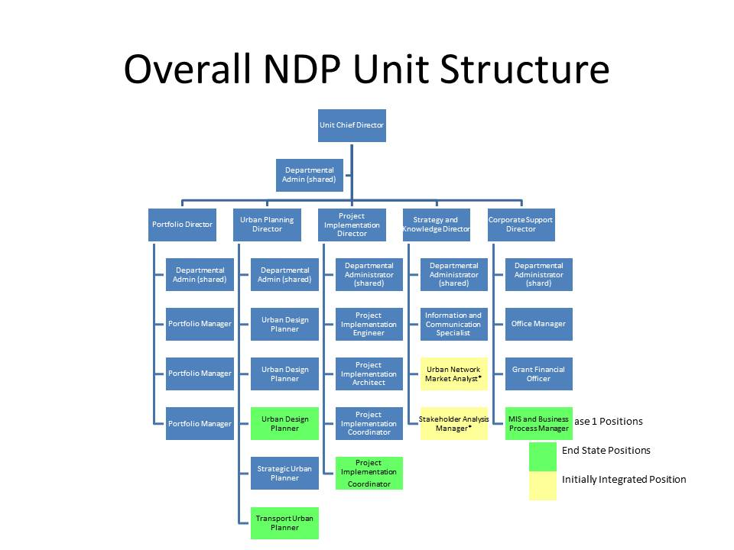

Figure 3: NDP Org Structure

## Legislative Mandate

This Policy will be guided by amongst others, the following legislation, government regulations, and industry best practices where practically applicable:

| **National Policy / Legislation** | **Government Regulations** | **Industry Best Practice** |
| --- | --- | --- |
| The national medium-term priorities (MTSF) | NT Strategy and Business Plans | Community / Stakeholder participation |
| Delivery agreements | NT Policies |  |
| The National Development Plan 2030 | Occupational Health and Safety Act and Regulations |  |
| The PFMA | Preferential Procurement Regulations |  |
| The MFMA | Housing Act and White Paper |  |
| The DORA | The White Paper on South African Land Policy |  |
| BBBEE Act | The Green Paper on Development and Planning |  |
| Construction Industry Development Board Act, 2000 | Town Planning Schemas / Regulations |  |
| Municipal Systems Act (Spatial Development Frameworks / Integrated Development Plans) |  |  |
| Development Facilitation Act (DFA) |  |  |
| The National Environment Management Act (NEMA) |  |  |

Table 1: Applicable Governance

These legislation, government regulations, and industry best practices are not necessarily an exhaustive list. As more detail is uncovered during the development and review of NDP policies, this list will be updated.

## Regulated Management Processes

In order to ensure an effective transformation of required input to required output, the processes as illustrated in the following figure will be executed:



Figure 4: NDP Management Processes

Within this business process model the high level process descriptions are as follows:

* Review / Plan Strategy. Strategic planning refers to high level, holistic, medium to long term planning focused on delivering and where necessary reviewing on the mandate of the NDPG. It provides clear direction amidst the always changing external and internal environment as well as catering for on-going adaption or improvements stemming from direct performance / compliance and impact / feedback from programmes and projects with stakeholders i.e. targeted municipalities.
* Review / Develop Frameworks / Policy / Procedures. Policy development refers to the internal development and review of rules, regulations and specifications with regard to all planned business process and supportive system elements. These rules can be defined as Policies, Procedures, Guidelines and Standards and will cover both the core, control and where necessary the support processes of the NDP Unit. All will comply within a wider National Treasury policy framework as to avoid any contradiction or duplication.
* Review / Plan Operations. Operational planning describes short-term ways of achieving milestones and explains how the NDP Unit’s strategic plan will be put into operation, given the mandate of the NDPG and the MTEF budgetary term. The operational plan is the basis for, and justification supporting the core, control and where necessary support activities. The plan includes the motivations for the annual operating / MTEF budget requests, the unit’s resource structure, internal and external communications and stakeholder management strategy / approach and forms the basis of the crafting / input for performance management compliance, assessments and review.
* Re / Control Performance / Compliance. Comparing actual business results with required business results in order to either accept the result or to change the performance baseline (plan) or compliance baseline (policy).
* Improve Business Practice. The congruent improvement of any identified business system element that negatively influences required performance and / or compliance.

# Policy Implementation

The following aspects must be considered during the implementation of this Policy:

* Responsibility and accountability within the NDP Management Policy is formalised as follows:



Table 2: Stakeholders Responsibilities

* The NDP Chief Director is accountable for all NDP processes. The Strategy and Communications Director has the responsibility to ensure the continued quality of all business processes and is also as process owner responsible for accurate functional content of the NDP Management processes.
* The implementation of this Policy requires the development and implementation of the following procedures that forms the basis of the NDP Management Policy:
  + NDP Strategic Planning
  + NDP Framework / Policy / Procedure
  + NDP Operational Planning
  + NDP Performance / Compliance Control
  + NDP Improve Business Practice
* Managers responsible for the implementation of this Policy need to ensure effective implementation within the different scopes of business.
* This Policy needs to be communicated to all stakeholders.

# Monitoring and Evaluation

This policy is supported by detailed procedures that define the compliance controls. These procedures must be reviewed at least annually as part of the governance review programme. Performance and compliance reports must be provided at least on a quarterly basis to the DG, Audit and Risk Committees and must be used to effect improvements.

# Exceptions and Exemptions

This policy is supplementary to management policies and procedures within NT. NDP internal support is fully regulated by NT support policies and procedures. NDPG core business policies are seen as specifically designed to support the delivery of the NDPG mandate.

# Limitation and Conditions

This Policy overrides any other NDP internal management policy that is not consistent with its provisions, unless such deviations are within the scope of ordinary activities and in the best interest of the department, and are approved by the accounting officer.

# Non-Compliance with Policy

All employees who wilfully or negligently fail to adhere to provisions of this Policy will be held liable for their actions and decisions, and disciplinary steps may be taken against such employees.

# Approval

The NDP Management Policy is hereby recommended and approved.

Recommendation

**DOUGLAS COHEN**

**Specialist Strategic Support / Quality Manager: NDP Unit**

**Date:**

Approval

**DAVID VAN NIEKERK**

**Chief Director:  NDP Unit**

**Date:**

1. Business systems within this context comprises of leadership, people, strategy, policy, resources, partnerships, processes and results. The binding factor within business systems are processes. Not to be confused with ICT systems, this should be seen in this context as a component of a business system.