

NATIONAL TREASURY NEIGHBORHOOD DEVELOPMENT PROGRAMME BUSINESS FRAMEWORK

|  |  |
| --- | --- |
| Compiled by: | D Cohen and D Korff |
| Author(s) | D Cohen |
| Reviewed by: | D Van Niekerk |
| Document Version: |  |
| Release Date: |  |
| Review Date: |  |

Document Classification:

Confidential

Document Approval

(Indicate ‘N/A’ where not applicable)

|  |  |  |  |
| --- | --- | --- | --- |
| Action | Name & designation | Signature | Date |
|  |  |  |  |
|  |  |  |  |
|  |  |  |  |
|  |  |  |  |
|  |  |  |  |
|  |  |  |  |

**Document Revision Control**

|  |  |  |  |
| --- | --- | --- | --- |
| Revision | Date | Author | Summary of changes |
|  |  |  |  |
|  |  |  |  |
|  |  |  |  |
|  |  |  |  |

Table of Contents

**Table of Figures** 3

1 Framework Introduction 4

2 Purpose 4

3 Objectives 4

4 Executive Overview 4

5 Framework Development 5

5.1 Legislative Mandate 5

5.2 NDP Business Principles 6

5.3 Framework Scope 8

5.4 Regulated Processes 8

5.5 Stakeholders & Responsibilities 9

6 Framework Implementation 10

7 Monitoring and Evaluation 11

8 Approval 11

Appendix A: Integrated Business Process Model 2

**Table of Figures**

Figure 1: The position of the NDP Business Framework within the Governance / Management Landscape 4

Figure 2: Key Elements of the NDP Framework Illustrated 5

Figure 3: NDP Scope 8

Figure 4: NDP Processes 9

Figure 5: NDP Responsibility Structure 10

# Framework Introduction

For the NDP business system to function optimally it should be ensured that the system is fully formalised and integrated. NDP management has also expressed a requirement to ensure that NDP business model complies to ISO9001:2008 principles. This NDP framework will have a particular position as an element of governance and is closely linked to the NDP Strategy. Although it will be driven by the NDP Strategy it will also inform the strategy. It has more of a regulative purpose as opposed to the directive purpose of the NDP Strategy. This position is illustrated in the following figure:



Figure 1: The position of the NDP Business Framework within the Governance / Management Landscape

# Purpose

This framework serves as the strategic business model for NDP Services.

# Objectives

This framework creates a starting point for the definition and formalisation of the regulatory aspects regarding the NDP business on a strategic level. The objectives include the following, to:

* Regulate the NDP Business Process.
* Regulate internal and external roles and responsibilities related to the NDP business process.
* Regulate the principles guiding decision making within NDP.
* Drive the NDP policy development.

# Executive Overview

A deliberation of the NDP capability required to support the NT Strategy led to a set of conclusions which will influence the NDP business system of the future. These conclusions are illustrated in the following figure:

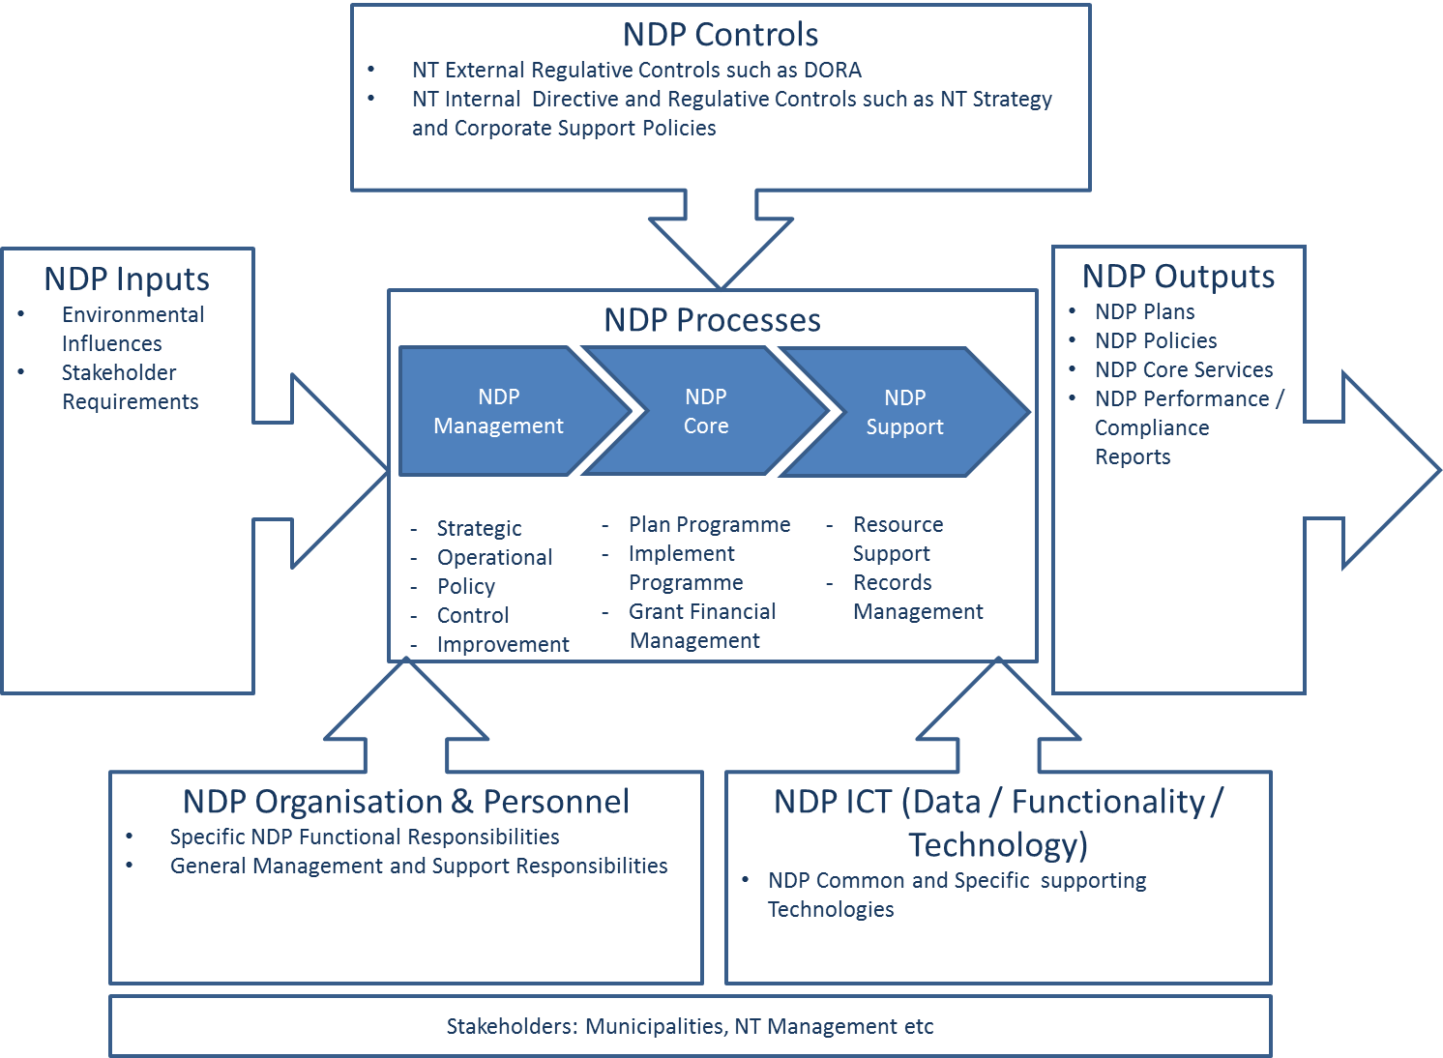

Figure 2: Key Elements of the NDP Framework Illustrated

The necessary NDP outputs have been identified with the key output being NDP core Services. In order to produce the required outputs, the NDP processes must be planned, the plans must be operationalized and the NDP planning and operations must be controlled. The inputs required to be transformed to the required output by the core processes are primarily stakeholder requirements and environmental influences with regard to the planning processes. NDP planning will be influenced by higher level strategy and policies and emerging best practices. A key influencing control is the DORA with regard to the NDP core business. Strategic NDP decision-making will adhere to principles such as a Partnership led approach, Value-for-money; Long term impact and Innovation and mainstreaming. Stakeholders of the NDP were grouped into those with a direct involvement with the NDP process and those with an interfacing involvement. Stakeholders directly involved are NDP Management, core and support business operators. Stakeholders indirectly involved are primarily the various municipalities but also other NT departments. The NDP process will be dependent on effective internal support. Requirements for these capabilities will mostly be communicated with NT Corporate Services. Most of the mentioned elements will be further discussed and defined within the framework development part.

# Framework Development

## Legislative Mandate

The Neighbourhood Development Partnership Grant (NDPG) was announced by the Minister of Finance in his budget speech of 15 February 2006. In this speech, the Minister stated that:

*“We will introduce this year a new grant programme for local development projects – this will specifically target public-private partnerships to invest in infrastructure and community services in low-income residential neighbourhoods.”[1] This signaled the establishment of the NDPG as a conditional grant to incentivise township-focussed partnerships in targeted municipalities.*

The Neighbourhood Development Programme Unit (NDPU), set up to administer the Neighbourhood Development Programme, is a Chief Directorate located within NT’s Public Finance and Budget Management Group (Programme 2), sub programme “Technical and Management Support”. The grant component of the SPU is located under Programme 8: Technical and Management Support and Development Finance”, being one of 3 conditional grants managed by the NT aimed to improve the pace and quality of infrastructure investment in municipalities.[2]

## NDP Business Principles

Decisions regarding NDP in NT will be guided by the following principles. These principles would be utilised to ensure compliance during the planning, operations and control processes:

### Partnership led approach

* **Short Description**: The NDP impact depends on successful working partnerships with multiple stakeholders and therefore should work with partners in planning and directing capital investment into projects that attract private sector investment.
* **Rationale** 
  + Improved partners trust leading into positive long-term working relationships.
  + Increased effectiveness in the use of the NDP’s resources to enhance public and private leverage and sector contribution and alignment to the SPU’s strategy, both financially and non-financially.
* **Implication**
  + Regular strategic engagement to communicate performance and understanding partner needs and expectations.
  + Ensuring that the objectives of the NDP are linked to partner needs and expectations.
  + Communicating partner’s needs and expectations throughout the NDP.
  + Measuring partner participation / engagement and project performance and acting on the results.
  + Systematically managing partner relationships.

### Value-for-money

* **Short Description**: Maximise value for public money.
* **Rationale** 
  + Encourages rigour and clarity about costs and outcomes.
  + Improved public sector coordinated infrastructure spending.
* **Implication**
  + Value-for-money can only be a relative measure through a comparison. One the comparison has been done, the monetary value assigned it no longer has any relevance or meaning, and is discarded, as it is merely an artefact of an economic comparison methodology.
  + Highlights that development outcomes must also be measured in other kinds of currencies – economic, environmental, social, political, security etc. – is not just about economic growth or schools or health, but about a complex mix of inter-related factors.
  + Supported the requirement for strong design, monitoring and evaluation to ensure that results can be attributed to the contribution.

### Long term impact

* **Short Description**: Plan and maximise for the long-term effects (benefits) and improve access by South Africans to healthcare facilities, schools, water, sanitation, housing and electrification and in the construction of ports, roads, railway systems, electricity plants, hospitals, schools and dams will contribute to faster economic growth.
* **Rationale** 
  + Cities form and grow to exploit economies of agglomeration.
  + Beneficial infrastructure projects aim to unlock long-term socio-economic benefits
  + Successful infrastructure-based development must combine various investments by the spheres and departments of government.
* **Implication**
  + The formation and sustainable growth of cities with the emphasis in supporting long-term sustainability.
  + To avoid a stop-start pattern of infrastructure roll-out.
  + Greater consideration of the impact of the economy that may or may not occur in the growth and formation of cities.

### Innovation and mainstreaming

* **Short Description**: The drive to bring about a coordinated approach for the spatial transformation of townships and urban areas into the mainstream through a process that shares knowledge and best practice and has a organisational structure with supporting processes and systems that encourage innovation and improvement.
* **Rationale** 
  + To ensure in alignment of Urban Networks Strategy is relevant within Vision 2030 and the Urban and Spatial focus of the National Development Plan.
  + The mainstreaming of spatial equity and spatial targeting in planning and development are important for sharing knowledge.
  + Innovation is about using change to better meet human needs and values.
  + The process of innovation is taking place within increasingly networked economies with changing social values and growing environmental pressures.
  + While these forces are unavoidable, they are not unmanageable.
  + Successful commercial approaches depend on having the flexible, multidisciplinary skills to respond to this changing context.
* **Implication**
  + Mainstreaming the strategy will considerations such as partnerships in the area of planning
  + Effective mainstreaming depends on the professional credibility of the approach
  + The NDP must prioritise the mainstreaming of best practices into development planning in order to ensure that the institutional structures and policy frameworks are to be put into place in order to effectively integrate migration into the development planning cycle.
  + Become a learning organisation that facilitates the learning process and continuously transforms itself through planning improvement / innovation.

## Framework Scope

The scope of this framework is equal to the scope of the NDP business system as illustrated in the following figure:



Figure 3: NDP Scope

The large rectangle in the middle represents the highest level NDP business process. The arrows entering the process from the top represent controls which governs the NDP business process. The arrows exiting the business process on the right represent outputs delivered and arrows on the left entering the process represent inputs required in the transformation to output. The arrows entering the bottom of the process represent mechanisms required to support the business process. The business process is performed by, each of the inputs / controls and mechanisms are provided to and outputs received by stakeholders. Stakeholders are defined in the next part. The NDP business process also has a decomposition which will be explained under the heading regulated processes. This scope and interfacing context (stakeholders) represent the total NDP business system requirement on the highest level.

## Regulated Processes

* In order to ensure an effective transformation of required input to required output, the processes as illustrated in the following figure will be executed:



Figure 4: NDP Processes

* Within this process model the NDP management process is the only process which deals with management direction, regulation, monitoring and evaluation of NDP core and support processes. The NDP core operations process deals with core processes producing external services / products. All the processes are dependent on NDP internal support processes. All the processes illustrated above will be explored in more detail during policy / procedure development.
* The integrated perspective of this process model is attached as appendix A.

## Stakeholders & Responsibilities

The NDP Business system interacts with or is directly supported by stakeholders. Stakeholder groups were identified by analysing the source of inputs, controls, mechanisms the destination of outputs and the executors of NDP business processes.

### Identified Stakeholders

* Other Government Departments
* National Planning Commission
* NT DG
* NT CFO
* NT Public Finance
* NT Budget Office
* NT Payments Office
* NT IGR
* NT CS
* Municipalities
* Service Providers
* CSIR

### Responsibilities

* Responsibilities for the various identified business processes are distributed to the organisation structure as illustrated in the following figure:

Figure 5: NDP Responsibility Structure

* These responsibilities will be specifically allocated to activities within the prescribed policies and procedures.

# Framework Implementation

The following aspects must be considered during the implementation of this framework:

* This framework will be implemented by NDP supported by NT Corporate Services.
* ***The implementation of this framework requires the development and implementation of four identified process driven policies. These policies are:***
  + ***NDP Management***
  + ***Plan Programme***
  + ***Implement Programme***
  + ***Grant Financial Management***
* ***The NDP will not develop its own support policies but will utilise and comply with the NT support policies.***
* Managers responsible for the implementation of this framework need to ensure effective implementation within the different scopes of business.
* This framework needs to be made available and shared with interested stakeholders.

# Monitoring and Evaluation

This framework must be reviewed at least annually as part of the governance review programme. Performance and compliance reports must be provided at least on a quarterly basis to the DG, Audit and Risk Committees and must be used to effect improvements.

# Approval

The NDP Business Framework is hereby recommended and approved.

Recommendation

**DOUGLAS COHEN**

**Specialist Strategic Support / Quality Manager: NDP Unit**

**Date:**

Approval

**DAVID VAN NIEKERK**

**Chief Director:  NDP Unit**

**Date:**

# Appendix A: Integrated Business Process Model

1. Budget Speech, 15 February 2006.
2. The 3 conditional grants managed by the NT are: the NDPG, the Infrastructure Grant to provinces and the Local Government Financial Management Grant.